
School Readiness
Preparing your child for starting school
Getting ready for school is an exciting time for children and their parents and carers, visiting school, shopping for uniform and knowing who your new teachers are going to be.
As the time for starting school approaches some children will be ready and take the move to school in their stride but others will need a little more help and encouragement from the adults in their lives.
In Blackburn with Darwen we have worked with Children Centres, Health, Childminders, Nurseries and Schools to agree what we mean by ‘school readiness’. These providers told us, in order to make sure that children are able enjoy school and get off to a good start they need to:
- have well developed personal skills -things like being able to put their coat on or feed themselves.
- have a level of emotional and social maturity - are happy to leave you and are used to playing with groups of other children
- have the ability to communicate, pay attention and learn - being able to talk to their teachers and sit for a story
- be healthy and well - so they have had all their injections and any health problems are being managed
We have put some ideas, hints and tips together in this information sheet about things that you can do to
help you to prepare your child for starting school. Keep it on your fridge or on a cupboard door so you can use different ideas each day.

Your child’s nursery or childminder may also share with you a document called ‘What to expect, when?’ This has lots of information about children’s development and what parents and carers can do to support them. You can also down load this from the following website:
https://foundationyears.org.uk/wp-content/uploads/2021/09/What-to-expect-in-the-EYFS-complete-FINAL-16.09-compressed.pdf
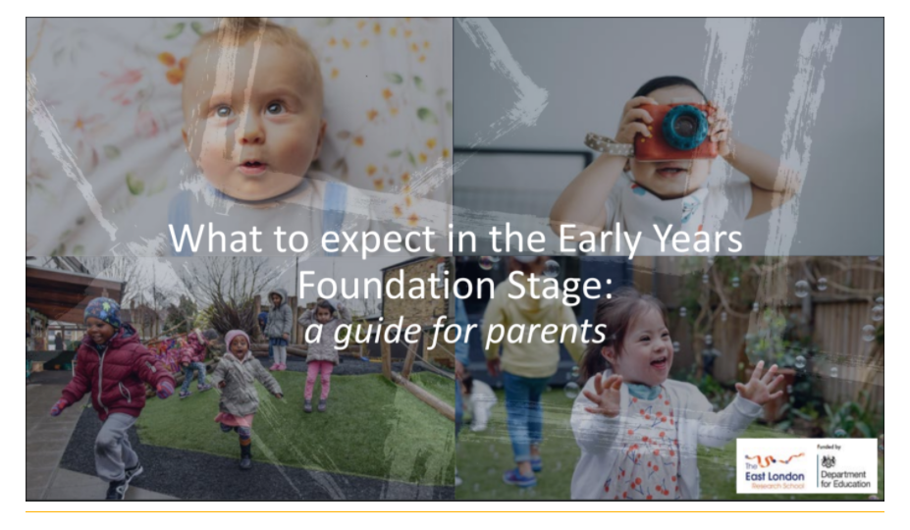

Your nursery or childminder will work in partnership with you to help you get your child ready for school, but there are other service that can offer advice, guidance and support such as your Health Visitor or your local Children’s Centre. If you would like any help and support you can contact your Health Visitor or Children’s Centre on: 01254 585000
Preparing your child for starting School
 | Attend all health checks and immunisations  Children will develop and learn if they are fit and healthy so make sure you keep up to date with all health checks including eye and hearing tests. And don’t forget those immunisations especially the boosters!  Speak to a Health professional or your child’s key worker if you have concerns and are worried about your child’s development or health and wellbeing
 | Good morning and night time routines  As early as possible try to establish a good morning and night time routine so that your child is not tired and has a positive and calm start to the day.
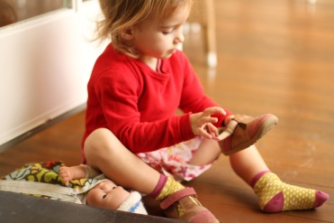 | Allow your child to be independent  Encourage your child to follow your instructions to put their own coat and shoes on and off, going to the toilet, washing their hands and feeding themselves independently.
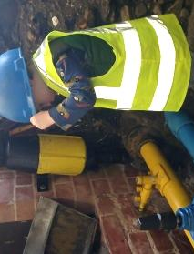 | Provide play opportunities and experiences  Allow your child to gain new experiences of the world and opportunities to play in different environments, and with different resources as this will develop and extend your child’s curiosity.
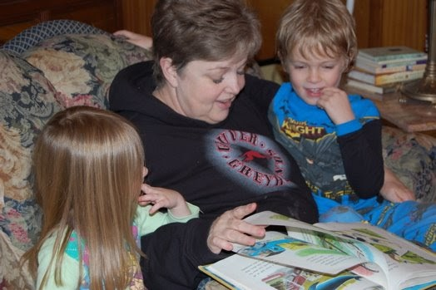 | Talk, read and sing with your child.  Allow time to ask your child questions and listen to their responses, read stories, look at books and sing songs with your child as much as possible to develop their speaking and listening skills ready for school.

Many parents think that their child needs to be able to read, write their own name, recognise numbers and letters or do sums to be ready for school. This is a myth. Some children may be able to do these things but it is more important is that they feel confident to have a go and try new things

I will be ready for school when… | How can you support me to do this?
I understand questions or instructions that have two parts, such as “Get your coat and wait at the door.” | - Play hide and seek games where I have to listen to your instructions.
I am able to talk about rhymes and books and tell a story. | - When we are sharing a story ask me how it might end.  - Ask me about the different pictures I can see on each page.
I use longer sentences of 4 -6 words. | - Encourage me to use longer sentences by allowing me time to talk and asking me lots of questions.
I use talk to organise my play and myself: “Let’s go on a bus, you sit there, I will be the driver.” | - Play with me and show me how to pretend to be a character and the types of things I could say whilst I am acting out my character’s role.
I can listen attentively and respond to what I hear. | - Read me a bedtime story before bed.  - Sing songs with me and rhymes that I can make actions to like heads, shoulders, knees and toes and wind the bobbin up etc.…  - Make up stories whilst we are walking so I can listen to them and tell you one too.
I play with at least one or more children, extending and elaborating my ideas. | - Take me to Toddler and Children Centre Groups. (play groups?)  - Let me play with other children in the park and on outings.  - Let me talk to other adults when you are there.
I follow rules and can understand why they are important. | - Make sure I know what I’m allowed to do and not allowed to do.  - Give me boundaries and make sure I keep to them.  - Let’s make some house rules together.
I can talk about my feelings using words like: happy, sad, angry and worried. | - Read books like Owl Babies and Peace at Last so we can talk about how the different characters are feeling.  - Ask me questions about how I feel.  - Tell me how you are feeling.
I can share and take turns in a group. | - Play games with me where I have to wait until it’s my turn to go.  - Make sure I take turns at the park and on outings.  - Talk to me about why I need to share my toys.
I am independent when meeting my own care needs such as: brushing teeth, going to the toilet, feeding myself and washing my hands. | - Encourage me to go to the toilet independently and wash my own hands and brush my teeth. I know it may take a little extra time however you are teaching me to do it all by myself.
I know and understand the importance of healthy life choices such as exercise, eating healthy foods, personal hygiene, teeth brushing etc… | - Teach me to use a knife, fork, and spoon and make sure I don’t just eat with my hands.  - Provide a variety of meals so I can experience a range of foods.  - Let me help you prepare meals so I can talk about foods and you can teach me new things.
I can skip, hop, stand on one leg and hold a pose for a game like musical statues. | - Take me outside to play as much as possible and teach me games like ‘Simon say’s etc…
I can use a comfortable grip with good control when using pens and pencils. | - Let me help you peg out the washing.  - Let’s play with playdough so I can use my finger muscles.  - Let’s draw pictures on the path and paving stones with chunky chalks.
I can get dressed and undressed independently, for example putting my own coat and shoes on and doing up zips. | - Show me my new school uniform and let me practice buttons and zips.  - Show me how to take off my clothes and put them in a pile on a chair ready for PE lessons.  - Buy me some Velcro fastening shoes that I can put on and take them off by myself.
I have good phonological awareness and can: spot and suggest rhymes, count or clap syllables in a word, and recognise words with the same initial sound such at hat and hop, sat and sip. | - Talk to me about the different sounds in words and play games such as I spy so I can start to think about the different sounds in words.
I can engage in extended conversations about stories, learning new vocabulary. | - Always ask me questions and involve me in conversations where I have to give you an extended answer rather than just a yes or a no.  - When we are out walking, talk to me about the new experiences that I may be seeing.
I can use print and letter knowledge in my early writing e.g. writing a pretend shopping list that starts at the top of the page. | - Model how to write a letter, card, postcard and shopping lists. I can then copy you whilst I am playing. Don’t worry if it just looks like marks and scribble – this is the start of my early writing.
I know that the last number reached when counting a small set of objects tells you how many there are in total (cardinal principle). | - Play games where I have to count my toys, ducks in the bath, stairs at home, cars in the street etc…
I can solve real world mathematical problems with numbers up to 5. | - Use puzzles, games and Jigsaws to explore problem solving.  - Talk to me about how much things cost and money when we are out shopping.
I can make comparisons to objects relating to size, length, weight and capacity. | - Bake with me and talk to me about weighing the ingredients and how much we may need.  - Talk to me about the different size of things I can see.
I understand the need to respect and care for the natural environment and all living things. | - Take me to the pet shop to show me different animals.  - Let me care for a pet.
I know that there are different countries in the world. I can talk about the differences that I have either experienced, read about or seen in photos or media. | - Let me watch programmes about the natural environment and the world.  - Take me to local library to look at pictures of what other countries look like and talk to me about the differences I may be able to see.
I can explore different materials freely, in order to develop my ideas about how to use them and the different creations I can make. | - Do some fun activities with me like – painting, junk modelling, wrapping presents and collage.  - You can teach me to use different tools such as scissors, glue sticks and staplers correctly.
I know and can sing a few nursery rhymes and/or songs. | - Allow me to explore different Nursery Rhyme books.  - Teach me rhymes that you remember and know.  - Let me listen and sing along to rhymes and songs at home and in the car where possible.

